

first(aB) = {a}

first(b) = {b}

first(cBB) = {c}

Passed

/Users/azureskyline/Desktop/Screen Shot 2016-09-25 at 7.29.02 PM.png

first(aB) = {a}

first(bA) = {b}

first(aBb) = {a}

Fails

/Users/azureskyline/Desktop/Screen Shot 2016-09-25 at 7.29.08 PM.png

first(aaA) = {a}

first(b) = {b}

first(caB) = {c}

Passed



Next token: 10

Next lexeme: a

Enter <expr>

Enter <term>

Enter <factor>

Next token: 21

Next lexeme: +

Exit <factor>

Exit <term>

Next token: 10

Next lexeme: b

Enter <term>

Enter <factor>

Next token: 10

Next lexeme: \*

Exit <factor>

Next token: 26

Next lexeme: c

Enter<factor>

Next token: -1

Next lexeme: EOF

Exit <term>

Exit <expr>

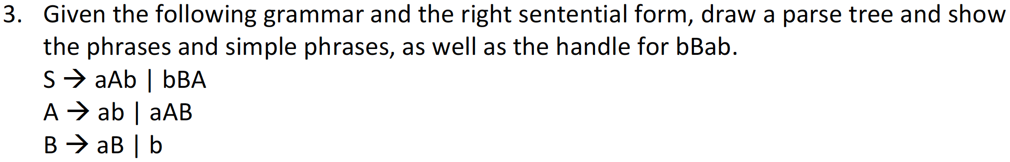

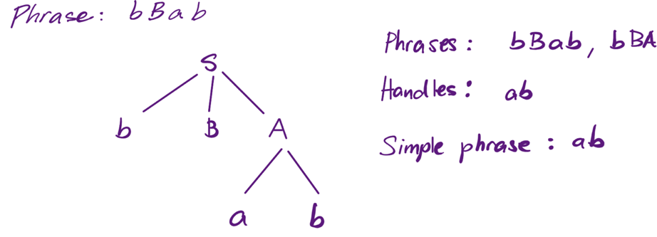

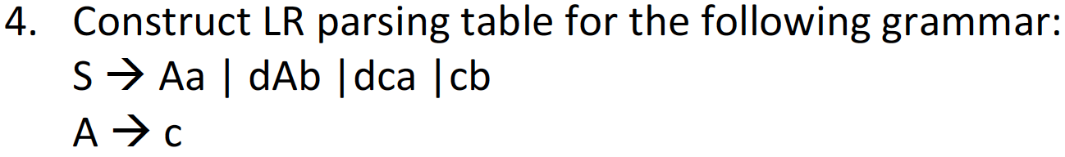

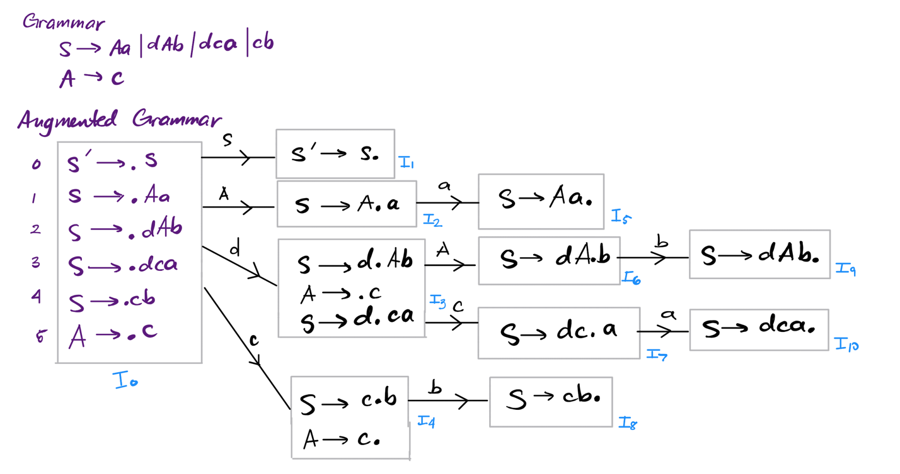

Parse Table:

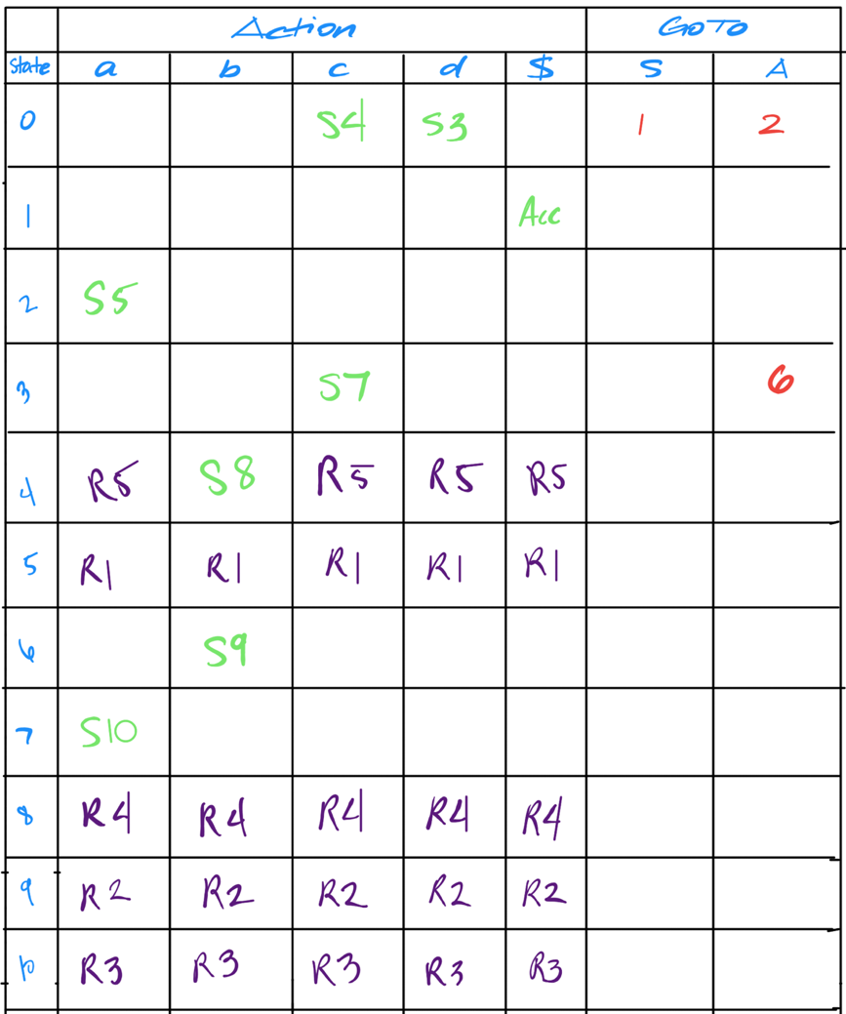



Stack Input Action

0 id \* (id + id) $ Shift 5

0id5 \* (id + id) $ Reduce 6 GOTO 0

0F3 \* (id + id) $ Reduce 4 GOTO 0

0T2 \* (id + id) $ Reduce 2 GOTO 0

0T2\*7 (id + id) $ Shift 7

0T2\*7(4 id + id ) $ Shift 4

0T2\*7(4id5 + id ) $ Shift 5

0T2\*7(4F3 + id ) $ Reduce 6 GOTO 4

0T2\*7(4T2 + id ) $ Reduce 4 GOTO 4

0T2\*7(4E8 + id ) $ Reduce 2 GOTO4

0T2\*7(4E8+6 id ) $ Shift 6

0T2\*7(4E8+6id5 ) $ Shift 5

0T2\*7(4E8+6F3 ) $ Reduce 6 GOTO 6

0T2\*7(4E8+6T9 ) $ Reduce 4 GOTO 6

0T2\*7(4E8 ) $ Reduce 1 GOTO 4

0T2\*7(4E8)11 $ Shift 11

0T2\*7F10 $ Reduce 5 GOTO 7

0T2 $ Reduce 5 GOTO 0

0E1 $ Reduce 2 GOTO 0

Accepted